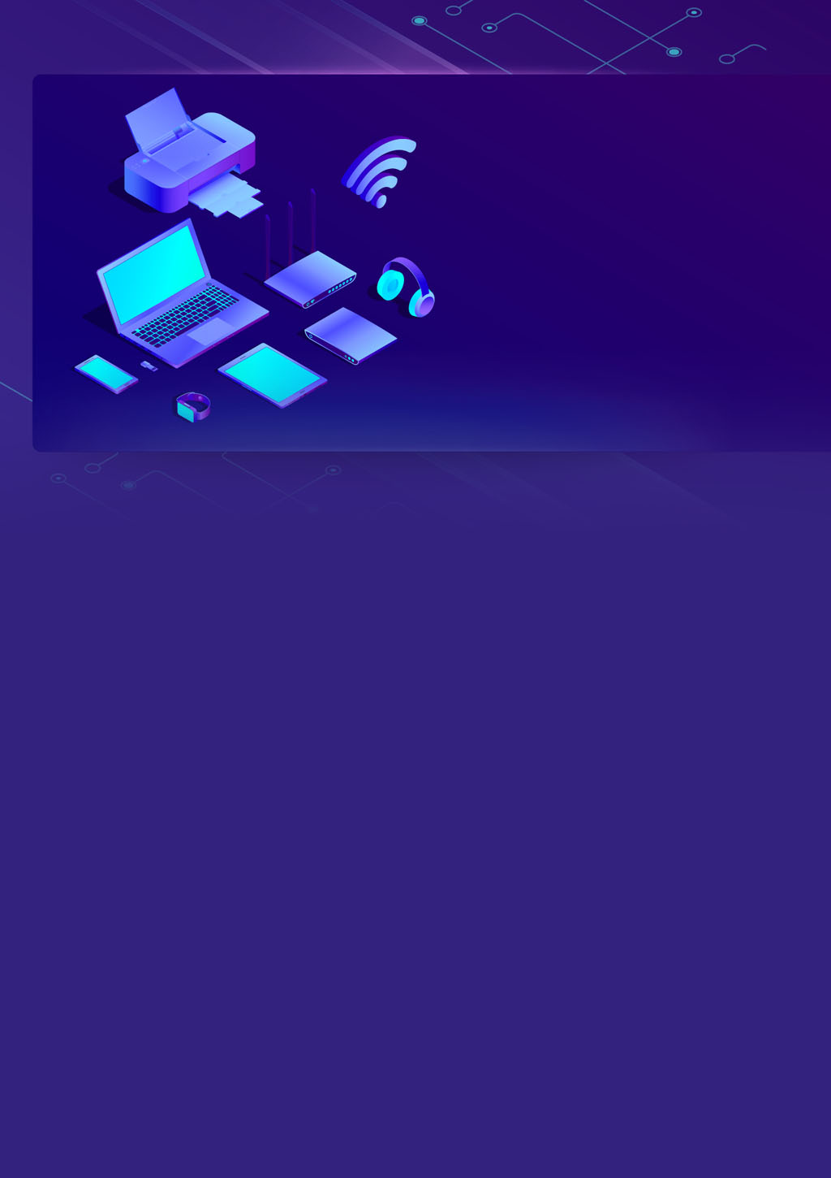

**Module 3 – Part A**

**Assignment**

**IOT internship**

**Team Members: -**

**TL: Mahmoud Essam Fathy: 20221460231**

**Ziad Ashraf Hafez Gaber: 20221374025**

**Ziad Ashraf Ibrahim Taher: 20221369225**

**Muhammad Ashraf: 20221372763**



**Module 3 Assignment Part A – Theoretical**

**< Different comparisons micro-controllers to micro-processors >**

**<Answer>**

**There are various similarities between the microprocessor and microcontroller as they perform relatively the same tasks. There exist differences between microprocessor and microcontroller which are elaborated in the table provided below on various factors**

|  |  |
| --- | --- |
| Microprocessor | Microcontroller |
|  |  |
|  |  |
|  |  |
|  |  |
|  |  |
|  |  |
|  |  |
|  |  |
|  |  |
|  |  |
|  |  |

**Is ESP32 a Microprocessor?**

**The answer is yes, the ESP32 is a microprocessor. ESP32 microprocessor is a chip-based system that offers a full range of functions, such as a microcontroller, as well as built-in capabilities for Wi-Fi and Bluetooth connectivity. The ESP32 can be programmed using the Arduino IDE or other development environments, making it easy to use for hobbyists and professionals alike.**

**The ESP32 is a type of microcontroller that is cost-effective along with low energy requirements. It has built-in Wi-Fi and can use both Bluetooth modes. It uses either a dual-core or single-core Tensilica Xtensa LX6 microprocessor or a single-core RISC-V microprocessor.**



**Module 3 Assignment Part A – Theoretical**

**< Compare digital signals to analog signal with at least 5 different Comparisons >**

**<Answer>**

|  |  |
| --- | --- |
| Analog signals | Digital signals |
|  |  |
|  |  |
|  |  |
|  |  |
|  |  |
|  |  |
|  |  |

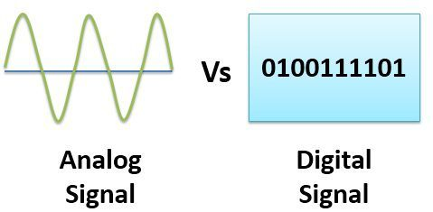

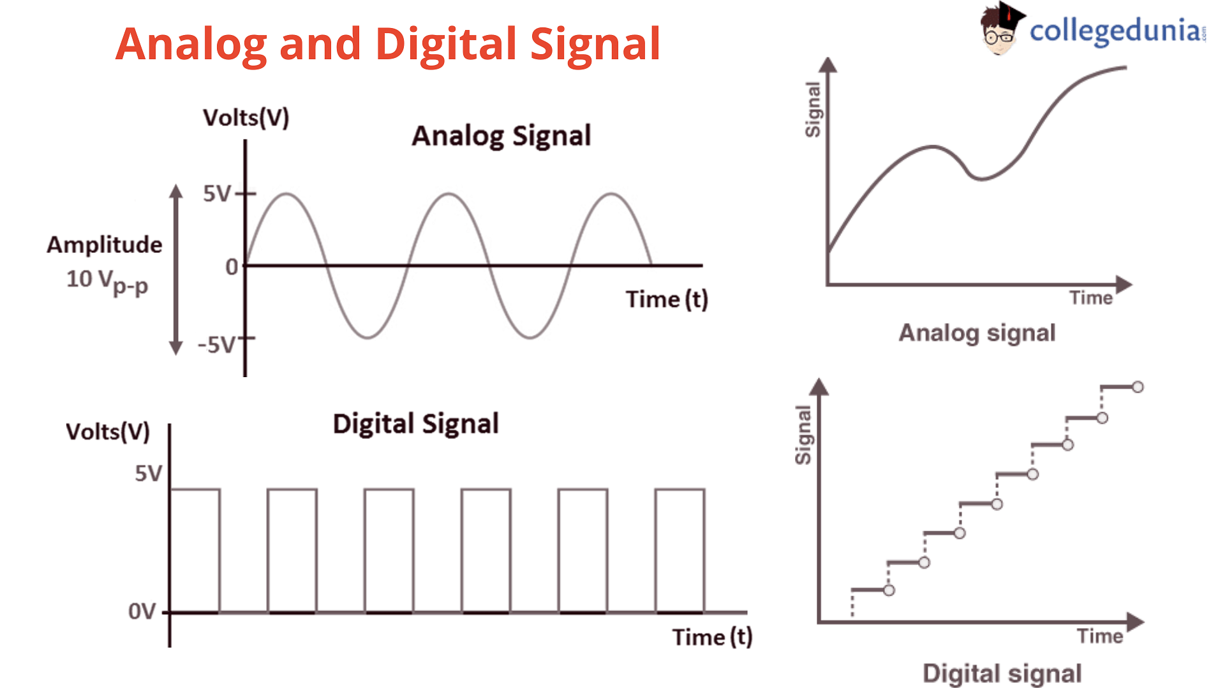

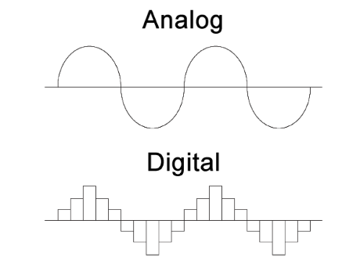



**Module 3 Assignment Part A – ESP32 Problem 1 (Bar Led)**

**Everything Provided in the folder “Videos – Circuits – Schematic – Real-life – and TinkerCAD action”**

**Description of connections**

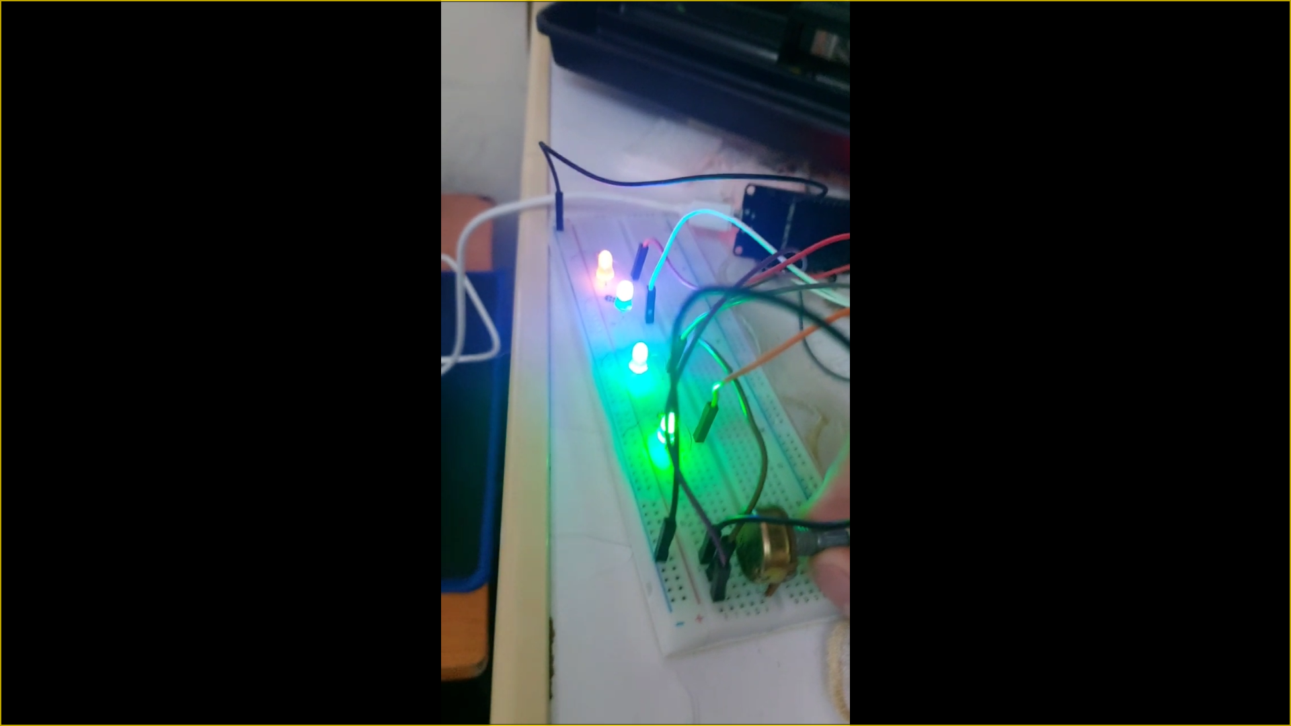



**Module 3 Assignment Part A – ESP32**

**Button Press**

**Description of connections**

**Everything Provided in the folder “Videos – Circuits – Schematic – Real-life – and TinkerCAD action”**

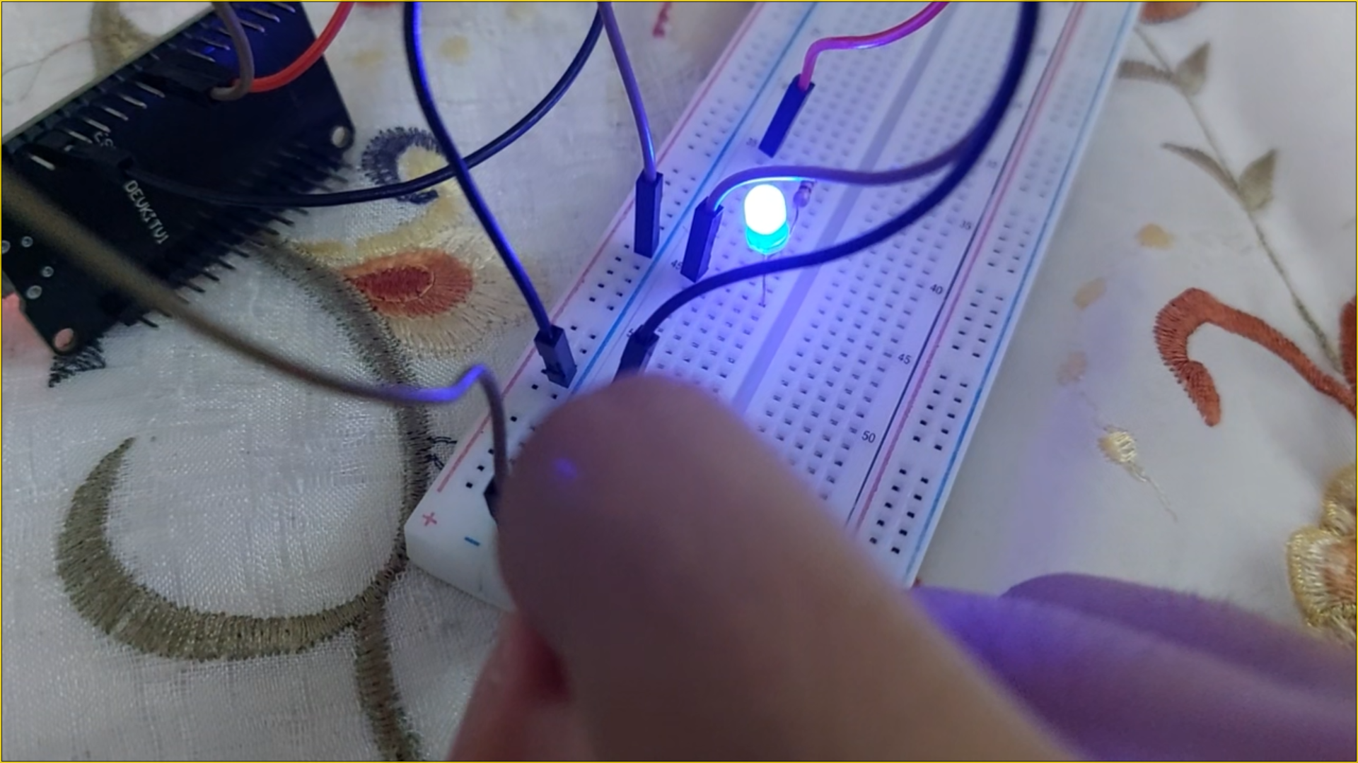



**Module 3 Assignment Part A – ESP32 Problem 1 (LDR Buzzr)**

**Everything Provided in the folder “Videos – Circuits – Schematic – Real-life – and TinkerCAD action”**

**Description of connections**

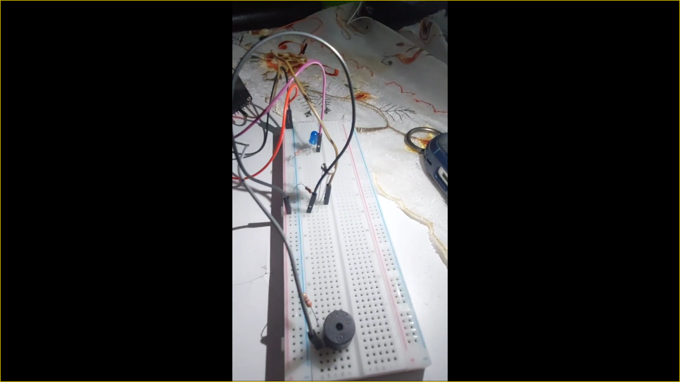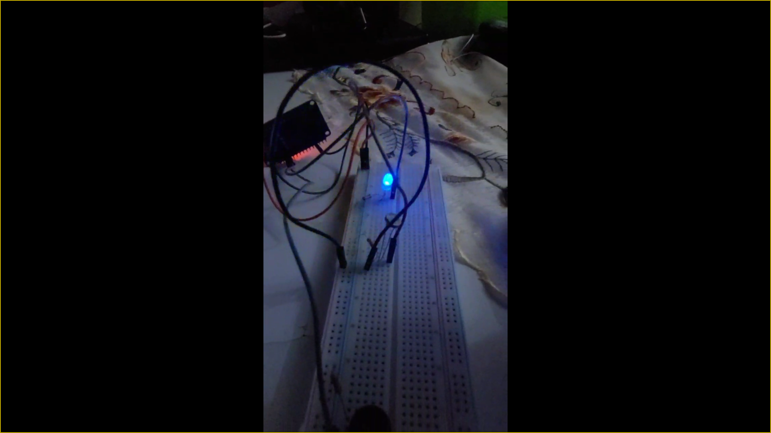



**Module 3 Assignment Part B – ESP32**

**Flame Sensor “Bonus”**

**Everything Provided in the folder “Videos – Circuits – Schematic – Real-life – and TinkerCAD action”**

**Description of connections**

